**User Manual**

**Basic Maze Game the Purpose is to reach the end of the maze to Run out , you will face Obstacles From Walls and Trees.**

**You will be bonused by Gifts , and will be given weapon to help you go through the Maze.**

**User controls :**

**For Player 1:**

The basic “arrows Control”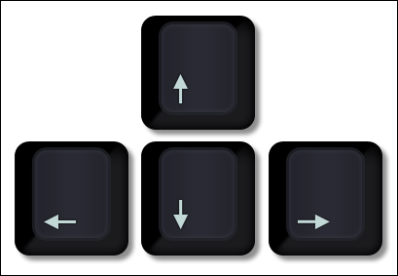

And to Use your Weapon Hit “SpaceBar”

**For Player 2:**

The “W A S D” Control

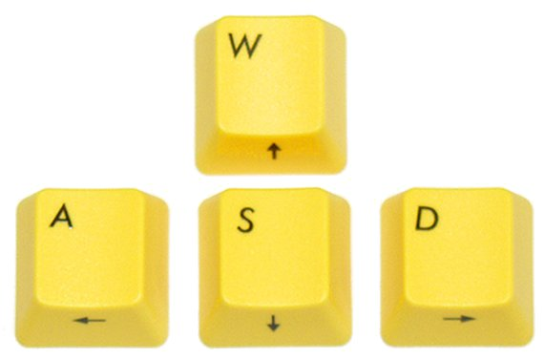

And to use your Weapon Hit “X”



**Maze Content:**

1-Players :

The Red Ball : player 1

The Blue Ball : player 2

2-Maze Walls:

The Wall you can’t go Through unless you got the Weapon

3-Maze Trees:

The Trees undestroyable , can’t be passed

4-Gifts:

Diamonds Raise Your game Score , the more you Collect the more Score you get

5-Weapons:

The Gun to get through walls to cut your way through the Maze

6-Bombs:

Bombs end your life , and make you lose

* these bombs end your life , can end be destroyed by Gun
* those can’t be destroyed

7-Monsters:

Monsters Kill you when they get near you , or you can kill them and win the game if you got the “Weapon”

8-Maze Gate:

When you reach it without Stepping on A bomb or Killed by a Monster. You”Win” the Game.

Maze preview

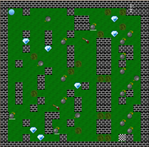

Created By :

Ramy A. Salama 2090

Myriam Reda Dimitry 2159

Mohamed Mahmoud Atef ElShaer 2211

Mohamed AbdElAziz 2340

Omar Kamal 2256

Sarah Mostafa Mahdy 1507

Thanks ☺